**Implementing script to know the Battery level of System/Laptop/IPad browser:**

Chrome Version: 66.0.3359.181 (Official Build) (64-bit)

**Description**: To know the battery level of system using navigator.getBattery() of JavaScript. This will return promise of battery and provides methods and properties like below

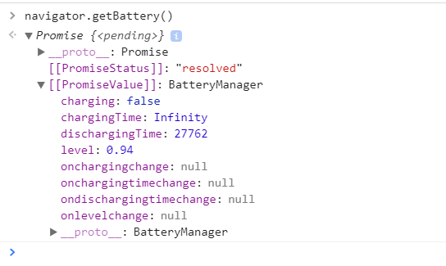

**Properties**:

**charging**: It gives the status of charging, if charger is plugged in it will gives true otherwise false.

**chargingTime**: It gives in how much time it full charge. If charger not plugged in it will gives Infinity otherwise gives proper time.

**dischargingTime**: It gives in how much time charging will dried. If charger unplugged it gives proper time, otherwise it gives Infinity.

**level**: It gives the level of battery of system. It gives value between 0 to 1.

**Methods**:

**onchargingchange**: It will return the charging state like charger plugged in or not.

**onchargingtimechange**: It will return charging time of system.

**ondischargingtimechange**: It will return discharging time.

**onlevelchange**: It will return changing level of system.

References:

<https://w3c.github.io/test-results/battery-status/20160621.html>

<https://www.w3.org/TR/battery-status/#dfn-realms>